Effect of net SIZE on estimates of abundance, size/age, and sex of *Mysis DILUVIANA*

D.B. Silver1,2, B.M. Johnson3, W.M. Pate3, K.R. Christianson3, J.R. Tipton4, and P.J. Martinez5

FOR: Limnology and Oceanography: Methods, J. Great Lakes Research, J. Plankton Research? “Note” for LRM? Hydrobiologia?

Keywords: mysis sampling, opossum shrimp, net efficiency

Running head: effects of net size on mysis estimates

1Corresponding author: [dugag@aol.com](mailto:dugag@aol.com), (xxx) xxx-xxxx

23891 East Irwin Place, Centennial Colorado 80122

3Department of Fish, Wildlife and Conservation Biology, Colorado State University, Fort Collins, Colorado 80523.

4 Department of Statistics, Colorado State University, Fort Collins, Colorado 80523.

5retired,Colorado Division of Parks and Wildlife, Grand Junction, Colorado

**Abstract**

We compared catches of *Mysis diluviana* in 80 vertical tows with large (1.0 m diameter) and small (0.5 m diameter) plankton nets to determine if the small net could be used in long-term monitoring historically conducted with the large net. Both nets were constructed of 0.500 mm aperture mesh and were towed simultaneously at 0.4 m/s. Comparisons were made at each of 10 sites on four dates during July-September, 2014 at Dillon Reservoir, Colorado. Estimates of population characteristics (abundance, size structure, and sex ratio) were not practically different between the two nets. We conclude that the two nets can be used interchangeably; the smaller net is more useful for studies with gear size and weight constraints, but the larger net provides a 4x larger sample size and thus may be better for detecting rare individuals.

**Introduction**

*Mysis*spp. are small (< 25 mm in body length) shrimp-like crustaceans. Two closely related and ecologically analogous species, *M. diluviana* and *M. relicta*, are native to deep, cold freshwater lakes of North America and Europe, respectively (Audzijonyte and Vainola 2005). Only recently were these two taxa considered separate species (Audzijonyte and Vainola 2005). Both species are omnivorous and perform diel vertical migrations, inhabiting benthic habitat during the day and migrating into the pelagic to feed on plankton after sunset (Beeton and Bowers 1982; Grossnickle 1982). Mysids can be very abundant (> 1,000 individuals/ m2) even in oligotrophic waters (Grossnickle and Morgan 1979; Caldwell and Wilhelm 2012) and hence play important roles in trophic dynamics of host systems (Rudstam and Johannsson 2009). Both species were widely introduced outside their native ranges by fisheries managers during the twentieth century with unexpected and generally negative impacts (Lasenby et al. 1986; Nesler and Bergersen 1991). Instead of providing a new food source for sport fish, anti-predation behavior allowed introduced *Mysis* to avoid most piscine predators, and they competed with fish for zooplankton (Lasenby et al 1986; Northcote 1991). Direct and indirect effects of *Mysis* introductions resulted in the collapse of numerous salmonid fisheries in the western United States (Martinez et al. 2009). Today, regular sampling of mysid populations is necessary to understand and manage their role in food webs, effects on water quality, and competition with fish populations (Ellis et al. 2011; Caldwell and Wilhelm 2012; Johnson and Martinez 2014).

Quantitative sampling of mysids is complicated by their association with the substrate by day where they may be difficult to observe or capture, and their movements in the water column at night. Accordingly, mysid populations have been sampled with different methods at different times of day. During daytime, quadrat counts (Lasenby 1971) and epibenthic sleds or trawls (Furst 1972; Maiolie and Bergersen 1991) have been used but such methods can underestimate abundance compared with net tows at night when mysids are pelagic (Grossnickle and Morgan 1979; Nero and Davies 1982). While nocturnal vertical tows with plankton nets appear to be the most common sampling approach, an informal survey of the literature showed that a variety of net configurations that could differ in their sampling efficiency and selectivity have been used (Table 1). Most investigators have used simple conical plankton nets but Bongo, pyramidal, and closing nets have been used. Net opening diameters of 0.30 (Kjellberg et al. 1991; Griffiths 2007) to 1.08 m (Brownell 1970) have been used but the most common diameter was 1.00 m, followed by 0.50 m diameter. Net lengths were only reported in a third of studies but ranged 1.4 -5.0 m. Mesh aperture sizes ranged 0.130 mm (Lehman et al. 1990) to 1.350 mm (Rumsey 1985) with 0.500 mm being the most common mesh. Very few investigators reported tow speed (range: 0.3 -1.0 m/s) or using flow meters to measure filtration volume.

Because net dimensions, mesh aperture size, and tow speed all affect the performance of plankton nets (de Bernardi 1984), the lack of standardized sampling protocols makes comparisons among *Mysis* studies difficult. Controlled studies that evaluate the effects of net configuration on estimates of population characteristics are needed to identify potential biases due to sampling methodology. In this study we compared the catch from two commonly used *Mysis* nets, testing for differences in population density (n/m2), size structure, and sex ratio. Comparisons were repeated over a three month period to account for possible differences in *Mysis* demographics or ambient conditions that could affect sampling characteristics of the nets.

**Methods**

Sampling was conducted at Dillon Reservoir, a large (1,335 ha) montane (2,750 m ASL) reservoir in central Colorado (39°36.554’ N 106°03.665’ W). Mean and maximum depths are 23 m and 66 m, respectively. Dillon Reservoir has been characterized as mesotrophic (summer TP=6 μg/L, chl-a=7 μg/L, Secchi=3.4 m) (Lewis et.al. 1984; Johnson, unpublished data). The reservoir is dimictic and ice-free during May through mid-November. Surface temperatures rarely exceed 18 °C and oxygen concentrations below 4 mg/L have not been observed (Lewis et.al. 1984; Johnson, unpublished data). *Mysis diluviana* were introduced into Dillon Reservoir in 1970 and established a large population throughout the reservoir (Martinez et al. 2010).The population exhibits a one-year life cycle, with some individuals attaining a maximum length of about 24 mm by late fall.

We sampled with two net sizes. Each conical net had 0.500 mm aperture Nitex mesh attached to a steel ring. Three lines connected the steel ring to a central attachment point for a single tow rope. Each net terminated with a removable cup with 0.500 mm Nitex mesh. The larger net had a diameter of 1.0 m and was 3.0 m long. This net was adopted for standardized sampling of Colorado’s Mysis populations in 1991 (Martinez 1992) and was used to sample 14 large reservoirs regularly during 1991-2009 (Martinez et al. 2010). The smaller net had a diameter of 0.5 m and was 2.0 m long. We developed this net for sampling in remote locations where nets needed to be towed by hand from a small raft. Because we were interested in maintaining compatibility with the historic database, we needed to know if the smaller net had similar sampling characteristics as the large net. To test this we sampled with both nets simultaneously in a reservoir with Mysis density close to the statewide average and compared resulting population density (n/m2), size structure, lifestage composition, and sex ratio.

Sampling took place on two consecutive nights in July (results pooled) and on single nights in August and September, 2014. Sampling stations coincided with those of Martinez et al. (2010).The 10 stations were selected from within three depth strata (<20 m, 20-40 m, and >40 m) and represented all of the major basins and regions of the reservoir (Figure 1). Sampling commenced at least 60 min after sunset during periods with no moon. Each net was deployed on its own davit, about 3 m apart. The nets were lowered simultaneously until the cups were within 1 m of the bottom, as guided by a depth sounder. Nets were allowed to rest for 60 sec and then retrieved simultaneously at a constant rate of 0.4 m/s with electric winches. We collected one sample with each net type at each of the 10 stations. The catch from each haul was preserved in 70% ethanol.

In the laboratory samples of mysids were transferred to distilled water and examined under a stereomicroscope at 7X magnification. Each individual was counted and classified as 1) juvenile (< 10 mm; Pothoven et al. 2000), 3) male (extended pleopods, Balcer et al. 1984), 4) female (brood pouch exposed), or 5) adult of undetermined gender (>10 mm and neither gravid nor male). Each mysid was measured (nearest 0.1 mm) along a dorsal line from the tip of the rostrum to the tip of the telson using a calibrated micrometer.

Total counts of the catch in each net sample were normalized to number per m2 based on the cross-sectional area of the net openings. Statistical analyses were performed using the R program for statistical analysis, with the α value set at 0.05.

[We measured filtration efficiency of each net in a flume tank at the CSU Hydraulics Laboratory. Water in the flume had conductivity, temperature, turbidity ___. Clogging of the nets was unlikely so differences in filtration efficiencies were due to net configuration only (mesh size, net dimensions). Flow velocity in the flume was set to 0.40 m/s and current meters suspended in the mouth of each net measured flow velocity inside the net. Filtering efficiency was computed as

SHOULD WE RUN TESTS AT LOWER AND HIGHER FLOW VELOCITIES SINCE THERE IS A RANGE IN THE LITERATURE, AND BECAUSE OUR NETS MIGHT PERFORM BEST AT DIFFERENT TOW SPEED THAN We CURRENTLY USE?]

To determine if there was any difference between the two sized nets, we have a few questions of interest. Our main questions of interest are 1) Is there a difference in density of *Mysids* caught between the two nets, 2) Is there a difference in mean length of *Mysids* caught between the two nets, and 3) Does the density when broken down by age and sex class differ between the two net sizes? Note that we will use count and density interchangeable in what follows because we normalize to a one area.

**Results**

*Mysid* density and length were highly variable across sites in each sampling month and in both nets, and the distributions of catches were all positively skewed (Figure 2). Mean density during the study was 232.7 ± 163 mysids/m2 (±SD), similar to the long term average for the reservoir (247.5 ± 106.9 mysids/m2) (B. Johnson, unpublished data). While there was no apparent temporal trend in density, mean length increased with time and the density of juveniles decreased with time, as would be expected for a population sampled during the growing season, post reproduction. The density of females and males ratio was also relatively stable over the course of the study. The relative frequency of adults of indeterminate sex increased during the study (Figure 3).

We now answer the three questions of interest posed above.

1. Is there a difference in density of *Mysids* caught between the two nets?

By looking at the distributions of counts across time (Figure 2A), we see that they are similar between net sizes, but the normality of the counts is questionable. In addition, we see little differences between the two net sizes, except for perhaps a spike in catches of about 120 by the small net in August. Because counts cannot be less that zero and often are right skewed, the assumption of normality in the data is questionable. Hence, methods like linear regression, t-tests, and ANOVA that assume normal distributions are not ideal, but, for completeness we begin with a paired t-test. From the paired t-test, we find that there is no significant difference ( = 0.069, = 39, -value = 0.945) in expected counts.

We test for a difference in density between the nets more formally by fitting a model to compare if the count of *Mysids* caught by the large net is the same as the count of *Mysids* caught by the large net, after normalizing for the area of the two nets and controlling for covariates. The class of models known as generalized linear models (glms) offers a rigorous solution for modeling count data. These models allow for regression models that account for the effects of covariates like in linear regression but do not assume a normal distribution. For count data, there are two natural distributions to use: the Poisson distribution and the negative binomial distribution. The Poisson distribution has the strong assumption that the mean equals the variance, which is often not met in practical datasets. In our data, the count means are and the count variances are , for the small and large nets, respectively. Therefore, we use a negative binomial model

where is the mean of the negative binomial distribution for sampling event and is an overdispersion parameter that allows for the mean and variance to be different. We model with covariates using the canonical log link function

where is the set of covariates for observation . Then we perform inference on our coefficients , where the interpretation of is a percent change in count per unit change in .

To test for a change in total counts between the two net sizes, we construct a negative binomial regression model that examines the effect of net size while accounting for date of sampling and sampling location. The results shown below show that there is no evidence of an effect on the number of counts observed between the two net sizes (-value = 0.095, -value=0.924).

1. Is there a difference in mean length of *Mysids* caught between the two nets?

First we examine the data visually to get a visual impression of the length data (Figure 2B and Figure 3). When looking at the distribution of lengths between the two net sizes, we see that the length distributions look quite similar across the different dates, with a general increasing trend through time. What stands out is that the small net catches about a quarter of the number of *Mysids*, as expected by the difference in net sizes, whereas the general shapes of the histograms appear quite similar across net sizes, suggesting there is not a difference in *Mysid* length distribution between nets across time.

When we plot the distribution of lengths between the net sizes with respect to sex class (Figure 4), the distributions look quite similar as well. This suggests that there is not a lot of difference in length distribution of *Mysids* between the two net sizes when broken down by sex class.

From the histogram of paired differences, it looks like there is some light evidence that the smaller net catches slightly smaller *Mysids*, although the distribution appears to be centered near 0. From the paired t-test, we find that there is a significant difference ( = -2.158, = 39, -value = 0.037) in expected counts, although the -value is close to the 0.05 level. Despite the statistically significant difference, the practical difference is quite small as judged by the histograms and small difference in mean *Mysid* size difference (-0.293 mm).

One could argue that because the larger net catches four times the number of *Mysids*, the large net is more likely to catch *Mysids* at the extremes of the size classes (either really small or really large *Mysids*). To account for this, we perform a paired t-test using a trimmed mean, removing the smallest and largest 5% of the lengths before calculating the sample mean. From the paired t-test using the trimmed means, we find that there is not a significant difference ( = -1.754, = 39, -value = 0.087) in expected counts, although the -value is close to the 0.05 level. As with the untrimmed means, the practical difference is quite small as judged by the histograms and small difference in mean *Mysid* size difference (-0.247 mm).

To better account for the different sample sizes (the group means are from unbalanced sample sizes), we fit a linear model and a robust linear model (that assumes overdispersion in the data). We start by checking for heterogeneity in the group variances. When looking at the distribution of sampling variance by sampling occasion (10 locations, 2 nets, and 4 different sampling dates gives 80 total sampling occasions), we see that there is some difference in variance of lengths by sampling occasion and Bartlett's test (-value = 7.4310^{-175}) and Levene's test (-values = 5.36110^{-145}).

To test if there is a difference in length of net sizes while accounting for heterogeneity, we use a weighted least squares regression where the weights are the inverse of the group variances as well as a robust linear regression. From the weighted least squares regression, we find that there is a statistically significant difference in mean *Mysid* length caught between the two nets ( = 2.134, -value = 0.033). Now, after accounting for the location, date, sex distribution, and heterogeneity of variance we find that the difference in mean length caught between the two net sizes is 0.086 mm. As a final analysis, we apply a robust regression, using an M-estimator model that accounts for heterogeneity in variance and presence of outlying observations. For the robust linear model, we still find statistically significant differences in mean length between the net sizes (-value = 2.09, -value = 0.037 on 9111 degrees of freedom), with the effect size 0.078 about the same as from the weighted linear model

Although the statistical tests using both the weighted linear model and the robust linear model show statistically significant differences in mean length caught between the net sizes, this is not unexpected because have very large sample sizes and and the regression coefficients are very small relative to the other sources of variation in the model. Of greater interest is whether the observed effect is of practical significance. The effect size of the mean length difference between the two net sizes is small (0.078mm) and the sample size is large (n = 9127). Given a large sample size, a hypothesis test will show statistical significance unless the population effect size is exactly zero (this explains why all of the p-values in the table above are less than 0.05). Therefore, the practical effect of a difference in mean length of 0.078mm on a species with a mean length of 10.351mm is small (this is the smallest effect of all the effects estimated by almost a factor of two) and a difference in means of this size is not of practical interest. Another measure of effect size is Cohen's which measures the difference in means relative to a pooled standard deviation. For our data, Cohen's =0.075, which implies that the effect of net size is quite small in terms of practical significance.

1. Does the density when broken down by age and sex class differ between the two net sizes?

The final question we wish to explore is whether the total counts when grouped into sex classes of male, female, juvenile, and unknown vary with net size or other covariates. A visual inspection of counts by sex class shows no difference in counts by net size, but does show a change in counts over time for each sex class. (Figure 5). Figure 6 shows the normalized count of sex class by date where there is a pattern of juveniles maturing to males and females as time progresses and an increase in unknowns as juveniles grow in size but are not sexually differentiated.

To test for a change in counts broken down by sex category between the two net sizes, we construct a negative binomial regression model that examines the effects of net size, date of sampling, sampling location, and sex class. The results show that there is no effect of net size on counts when controlling for sampling date, sampling location, and sex class (-value = 0.185, -value = 0.853).

We can also examine if the counts within a sex class are different between the net sizes. To begin, we compare the counts of juveniles between the two nets (Figure 2C), where we see no visual differences in the juvenile count between net sizes but di see a decrease in juvenile count through time, as expected. To test this formally, we construct a negative binomial model that controls for sampling date and station. From our model, we see that time of year and location are important in influencing the juvenile counts, but net size is not (-value = -0.731, -value = 0.465). Similar negative binomial regression models for counts of males and females show similar effects (-value = -0.571, -value = 0.568 and -value = 1.607, -value = 0.108 for males and females, respectively). Figure 2D shows that the sex ratio of females to males also appears to be similar between the two net sizes. For further details and R code of the analysis, see online appendix at <http://jtipton25.github.io/mysis/>.

**Discussion**

We found no difference in most characteristics of the *Mysis* population measured with 1.0 m and 0.5 m diameter plankton nets with identical mesh size and towed at equal speed. While it did appear that the large net sampled a broader size distribution than the small net, differences were probably not biologically relevant. Thus, these two nets can be used interchangeably without introducing sampling bias due to net size effects. This conclusion is robust considering the fact that we performed a large number of paired comparisons covering most of the limnetic area of the reservoir over a three month period. Our results are consistent with Kjellberg et al. (1991) who reported that density and size structure of *Mysis relicta* were comparable in 0.3-m and 1.0-m nets. Apparently, sampling efficiency of Mysis nets, the ratio of the number of organisms captured to the number of organisms present in the volume swept by the net (de Bernardi 1984), does not differ over a relatively broad range of net opening sizes.

Efficiency of plankton nets is also a function of filtration efficiency (the ratio of the volume of water passed through the net to the volume of water that would pass if there was no resistance to water flow). The ratio of the filtering area to the area of the net opening affects filtration efficiency, as does the size and abundance of particles in the water which can clog pores in the mesh. Tranter and Heron (1967) found that in general plankton nets needed a filtering area:opening area >3:1 for ≥ 85% filtration efficiency and > 5:1 for 95% efficiency. Our large net had a ratio of 7:1 and the small net had a ratio of 9:1 so both should have very high filtration efficiency in the absence of mesh clogging effects. The 0.500 mm aperture mesh we used probably reduces clogging by phytoplankton while preventing loss of small mysids possible with larger mesh apertures (Martinez 1992).

Our choice of mesh aperture and tow speed are similar to those used in other Mysis studies (mean = 0.569 mm, and 0.43 m/s, respectively; Table 1) so our findings should be relevant to other investigators. While there have been few designed comparisons of Mysis net configurations, existing evaluations also support the mesh and tow speed we used. Chipps and Bennett (1996) reported that densities of juvenile and adult mysids and length-frequency distributions were similar in 0.33 mm and 1.0 mm mesh nets towed at a speed similar to ours (0.44 m/s). Nero and Davies (1982) found that catches were not different at tow speeds of 0.125 - 0.5 m/s. Together, these studies suggest that our results are applicable across a range of mesh sizes and tow speeds that encompass most of the range of each reported in the literature (Table 1) .

Our conclusions about effects of net size should also be applicable to other Mysis populations. We performed our comparisons over a growing season when the age and size structure of the population changed significantly and yet these temporal changes had no effect on the outcome of the net comparisons. While the larger net captured more large (≥ 20 mm) individuals than the smaller net, it is not known if this was a simple random effect of the 4x larger sample size gathered by the larger net being more likely to detect rare individuals, or if there was net avoidance by large mysids. The fact that the large net also detected rare, smaller individuals that the small net did not supports the former hypothesis. Regardless, few *Mysis diluviana/M. relicta* populations are reported to have many individuals ≥ 20 mm (Ball et al. 2015; Beeton and Gannon 1991; Caldwell and Wilhelm 2012; Carpenter et al. 1974; Furst 1972; Kjellberg et al. 1991; Scharf and Koschel 2004; Tattersall and Tattersal 1951). Still, investigators specifically interested in rare individuals may wish to use the larger net to enhance sampling probability.

**Conclusions**

We found no practical difference in *Mysis* population characteristics measured with 1.0 m and 0.5 m diameter plankton nets with identical mesh size and towed at equal speed, although we did find that the larger net sampled a larger range of the distribution of *Mysids* which suggests that a large net would be preferred if the aim is to capture individuals at the extremes of the size distribution. Thus, the choice of net size can be dictated by practical constraints and the research questions of interest. When gear size and weight are important considerations, for example when sampling in remote locations or from small boats, the smaller diameter plankton net can be used without bias compared with a 1.0 m net. When size and weight constraints allow, the larger diameter net may be preferable because it captures approximately four times the size of sample obtained from the half meter net and therefore is more likely to sample rare individuals.

**Acknowledgements**

Orion McComas assisted with field and laboratory work. Thanks to Frisco Bay Marina and Summit County Sheriff’s Department for providing after-hours boat access to the reservoir.

**References**

Ahrenstorff TD, Hrabik TR, Stockwell JD, Yule DL, Sass GG. 2011. Seasonally dynamic diel vertical migrations of *Mysis diluviana*, Coregonine fishes, and Siscowet Lake Trout in the pelagia of western Lake Superior. Transactions of the American Fisheries Society 140:1504-1520.

Bagge, P., H. M. Liimatainen, and P. Liljaniemi. 1996. Comparison of sampling methods for semipelagic animals in two deep basins of Lake Saimaa. Hydrobiologia 322:293-300.

Balcer, M.D, N.L. Korda, and S.I. Dodson. 1984. Zooplankton of the Great Lakes. University of Wisconsin Press, Madison, Wisconsin. Ball et al. 2015

Ball, S. C., T. B. Mihuc, L. W. Myers, and J. D. Stockwell. 2015. Ten-fold decline in *Mysis diluviana* in Lake Champlain between 1975 and 2012. Journal of Great Lakes Research IN PRESS.

Beattie and Clancy. 1991. Effects of *Mysis relicta* on the zooplankton community and kokanee population of Flathead Lake, Montana. American Fisheries Society Symposium 9:39-48.

De Bernardi, R. 1984. Methods for estimating zooplankton abundance. Page 59-86, In Downing, J. A., and F. H. Rigler, editors. A manual on methods for the assessment of secondary productivity in fresh waters. Blackwell Scientific, Oxford.

Beeton and Gannon. 1991. Effect of environment on reproduction and growth of Mysis relicta. American Fisheries Society Symposium 9:144-148.

Brownell, W. N. 1970. Studies on the ecology of *Mysis relicta* in Cayuga Lake. Master’s thesis, Cornell University, Ithaca, New York. 76 pages.

Caldwell, T. J. and F. M. Wilhelm. 2012. The life history characteristics, growth and density of Mysis diluviana in Lake Pend Oreille, Idaho, USA. Journal of Great Lake Research 38:58-67.

Carpenter GF, Mansey EL, Watson NHF. 1974. Abundance and life history of *Mysis relicta* in the St. Lawrence Great Lakes. Journal of the Fisheries Research Board of Canada 31:319-325.

Chipps, S. R., and D. H. Bennett. 1996. Comparison of net mesh sizes for estimating abundance of the opossum shrimp *Mysis relicta* from vertical hauls. North American Journal of Fisheries Management 16:689–692.

De Bernardi, R. 1984. Methods for the estimation of zooplankton abundance. In Downing J.D., Rigler F.H., editors. A manual on methods for the assessment of secondary productivity in fresh waters, second edition. Oxford: Blackwell Scientific Publications.p. 59-86.

Fürst, M. 1972. Life cycles, growth rate and reproduction in Mysis relicta Loven. Information fran Sotvattens-Labriet, Drottingholm, No. 11. 41 pp.

Gal G, Rudstam LG, Greene CH. 1999. Acoustic characterization of *Mysis relicta*. Limnology and Oceanography 44:371-381.

Griffiths, D. 2007. Effects of climatic change and eutrophication on the glacial relict, *Mysis relicta*, in Lough Neagh. Freshwater Biology 52:1957-1967.

Grossnickle NE, Morgan MD. 1979. Density estimates of *Mysis relicta* in Lake Michigan. Journal of the Fisheries Research Board of Canada 36:694-698.

Johannsson, O. 1992. Life history and productivity of *Mysis relicta* in Lake Ontario. Journal of Great Lakes Research 18:154-168.

Kjellberg, G., D. O. Hessen and J. P. Nilssen. 1991. Life history, growth and production of *Mysis relicta* in the large fiord-type Lake Mjøsa, Norway. Freshwater Biology 26:165-173.

Koksvik, J. I., H. Reinertsen, andJ. Koksvik. 2009. Plankton development in Lake Jonsvatn, Norway, after introduction of *Mysis relicta*: a long-term study. Aquatic Biology 5:293-304.

Langeland et al. 1991. Impact of predation by *Mysis relicta* and fish

Langeland et al. 1991. Impact of the introduction of *Mysis relicta* on

Lasenby, D. C., T. G. Northcote, and M. Furst. 1986. Theory, practice, and effects of *Mysis relicta* introductions to North American and Scandanavian lakes. Canadian Journal of Fisheries and Aquatic Sciences 43:1277-1284.

Lehman JT, Bowers JA, Gensemer RW, Warren GJ, Branstrator DK. 1990. *Mysis relicta* in Lake Michigan: abundances and relationships with their potential prey, *Daphnia*. Canadian Journal of Fisheries and Aquatic Sciences. 47: 977-983.

Lewis, W.M., Saunders, J.F., Crumpacker, D.W. and Brendecke, C., 1984. Eutrophication and Land Use, Lake Dillon, Colorado. Ecological Studies 46, Springer-Verlag. 202 pages.

Liljendahl-Nurminen, A., J. Horppila, L. Uusitalo, [Niemistö](http://link.springer.com/search?facet-creator=%22Juha+Niemist%C3%B6%22), J. 2008. Spatial variability in the abundance of pelagic invertebrate predators in relation to depth and turbidity. Aquatic Ecology 42:25-33.

Martinez, P. J. 1992. Coldwater reservoir ecology. Progress Report, Federal Aid in Sport Fish Restoration Project F-85. Colorado Division of Wildlife, Fort Collins, Colorado.

Martinez PJ, Gross MD, Vigil EM. 2010. A compendium of crustacean zooplankton and *Mysis diluviana* collections from selected Colorado reservoirs and lakes: 1991–2009. Special Report 82, Colorado Division of Wildlife, Fort Collins, CO.

McDonald ME, Crowder LB, Brandt SB. 1990. Changes in *Mysis* and *Pontoporeia* populations in southeastern Lake Michigan: A response to shifts in the fish community. Limnology and Oceanography 35:220-227.

Morgan MD. 1980. Life history characteristics of two introduced populations of *Mysis relicta*. Ecology. 61:551–561.

Næsje, TF, Jensen AJ, Moen V, Saksgärd R. 1991. Habitat use by zooplankton, *Mysis relicta*, and Arctic Char in Lake Jonsvatn, Norway. American Fisheries Society Symposium 9:75-87.

Nero RW, Davies IJ. 1982. Comparison of two sampling methods for estimating the abundance and distribution of *Mysis relicta*. Canadian Journal of Fisheries and Aquatic Sciences. 39: 349-355.

Paterson, M. J., C. L. Podemski, L. J. Wesson, and A. P. Dupuis. 2011. The effects of an experimental freshwater cage aquaculture operation on *Mysis diluviana*. Journal of Plankton Research 33:25-36.

Pothoven SA, Fahnenstiel, GL, Vanderploeg HA, Luttenton M. 2000. Population dynamics of *Mysis relicta* in southeastern Lake Michigan, 1995-1998. Journal of Great Lakes Research26:357-365.

Pothoven SA, Fahnenstiel, GL, Vanderploeg HA. 2010. Temporal trends in *Mysis relicta* abundance, production, and life-history characteristics in southeastern Lake Michigan. Journal of Great Lakes Research 36:60-64.

Richards, R., C. Goldman, E. Byron, and C. Levitan. 1991. The mysids and lake trout of Lake Tahoe: a 25 year history of changes in the fertility, plankton, and fishery of an alpine lake. American Fisheries Society Symposium 9:65–74.

Rudstam LG, Schaner T, Gal G, Boscarino BT, O’Gorman R, Warner DM, Johannsson OE, Bowen KL. 2008. Hydroacoustic measures of *Mysis relicta* abundance and distribution in Lake Ontario. Aquatic Ecosystem Health and Management 11:355-367.

Rumsey, S. 1985. Mysis monitoring in western Montana lakes, 1983-1984. Supplement to Progress Report F-7-R-34, Job I-a. Montana Department of Fish, Wildlife, and Parks, Kalispell.

Scharf, J; Koschel, R. 2004. Distribution, abundance and life history of *Mysis relicta* (LOVEN) in the Feldberg Lake District, Germany. Limnologica 34:199-212.

Shea MA, Makarewicz JC. 1989. Production, biomass, and trophic interactions of *Mysis relicta* in Lake Ontario. Journal of Great Lakes Research15:223-232.

Spencer, C. N.; D. S. Potter, R. T. Bukantis, and J. A. Stanford. 1999. Impact of predation by *Mysis relicta* on zooplankton in Flathead Lake, Montana, USA. Journal of Plankton Research 21:51-64.

Stockwell, J. D., D. L. Yule, T. R. Hrabik, M. E. Sierszen, and E. J. Isaac. 2014. Habitat coupling in a large lake system: delivery of an energy subsidy by an offshore planktivore to the nearshore zone of Lake Superior. Freshwater Biology 59:1197-1212.

Tattersall, W. M. and O. S. Tattersall. 1951. British Mycidacea. Ray Society, London.

Tranter, D. J. and A. C. Heron. 1967. Experiments on filtration in plankton nets. Australian Journal of Marine and Freshwater Research 18:89-111.

Watkins, J. M., L. G. Rudstam, M. J. Connerton, T. Schaner, P. G. Rudstam, and K. L. Bowen. 2015. Abundance and spatial distribution of *Mysis diluviana* in Lake Ontario in 2008 estimated with 120 kHz hydroacoustic surveys and net tows. Aquatic Ecosystem Health and Management 18:63-75.

Table 1. Configurations of vertical tow nets used for sampling *Mysis* *diluviana* or *M. relicta* populations from an informal survey of the literature. NR = not reported. Only one instance of a net type/investigator/location was recorded to reflect the diversity of approaches among investigators.

|  |  |  |  |  |  |  |
| --- | --- | --- | --- | --- | --- | --- |
| Net type | Net mouth size (m) | Net length (m) | Mesh size (mm) | Tow speed (m/s) | Reported by | Location |
| Bongo net | 0.50 | NR | 0.571 | NR | Shea and Makarewicz (1989) | Lake Ontario |
| Bongo net | 0.75 | NR | 0.202 | NR | Richards et al. (1991) | Lake Tahoe, CA-NV |
| Bongo net | 0.75 | NR | 0.500 | NR | Morgan (1980) | Lake Tahoe, CA-NV |
| Closing net | 1.00 | NR | 0.130 | NR | Lehman et al. (1990) | Lake Michigan |
| Closing net | 1.00 | NR | 0.300 | NR | Lehman et al. (1990) | Lake Michigan |
| Closing net | 1.00 | NR | 1.000 | 0.30 | Rudstam et al. (2008) | Lake Ontario |
| Closing net | 1.00 | NR | 0.500 | NR | Næsje et al. (1991) | Lake Jonsvatn, Norway |
| Closing net | 1.00 | NR | 0.500 | NR | Spencer et al. (1999) | Flathead Lake, MT |
| Conical plankton | 0.30 | NR | 0.250 | NR | Griffiths 2007 | Lough Neagh, Northern Ireland |
| Conical plankton | 0.40 | 1.4 | 0.150 | 0.65 | Scharf and Koschel (2004) | Feldberg Lake District, Germany |
| Conical plankton | 0.41 | NR | 0.405 | NR | Bagge et al. 1996 | Lake Saimaa, Finland |
| Conical plankton | 0.84 | NR | 0.405 | NR | Bagge et al. 1996 | Lake Saimaa, Finland |
| Conical plankton | 0.50 | NR | 0.183 | NR | Liljendahl-Nurminen et al. 2008 | Lake Hiidenvesi, Finland |
| Conical plankton | 0.50 | NR | 0.250 | 1.00 | Ahrenstorff et al. 2011 | Lake Superior |
| Conical plankton | 0.50 | NR | 0.250 | 0.50 | Ball et al. 2015 | Lake Champlain, VT |
| Conical plankton | 0.50 | 2.0 | 0.333 | 0.44 | Chipps and Bennett 1996 | Lake Pend Oreille, ID |
| Conical plankton | 0.50 | 2.0 | 1.000 | 0.44 | Chipps and Bennett 1996 | Lake Pend Oreille, ID |
| Conical plankton | 0.65 | NR | 0.800 | NR | Langeland et al. (1991a) | Inland lakes in Ontario, Norway |
| Conical plankton | 0.73 | 2.3 | 1.000 | 0.30 | Watkins et al. 2015 | Lake Ontario |
| Conical plankton | 0.75 | 5.0 | 0.285 | NR | Foster and Sprules 2009 | 8 inland lakes, Ontario |
| Conical plankton | 0.75 | NR | 0.500 | NR | Paterson et al. 2011 | Lakes 373 and 375, Ontario |
| Conical plankton | 0.75 | NR | 0.571 | 0.33 | Grossnickle and Morgan 1979 | Lake Michigan |
| Conical plankton | 0.75 | NR | 0.571 | NR | Madeira et al. (1982) | Lake Michigan |
| Conical plankton | 1.00 | 3.0 | 0.500 | 0.37 | Martinez et al. (2010) | Colorado reservoirs |
| Conical plankton | 1.08 | 2.5 | 0.570 | NR | Brownell 1970 | Cayuga Lake, NY |
| Conical plankton | 1.00 | 3.0 | 1.000 | 0.33 | Caldwell and Wilhelm 2012 | Lake Pend Oreille, ID |
| Conical plankton | 1.00 | NR | 1.000 | 0.30 | Gal et al. 1999 | Cayuga Lake, NY, Lake Ontario |
| Conical plankton | 1.00 | 3.0 | 1.000 | 0.50 | Pothoven et al. (2010) | Lake Michigan |
| Conical plankton | 1.00 | 3.0 | 1.350 | 0.35 | Rumsey (1985) | Western MT lakes |
| Conical plankton | 1.50 | NR | 1.050 | 0.50 | Bowers and Vanderploeg (1982) | Lake Michigan |
| “Framed net” | 0.50 | NR | 0.243 | NR | McDonald et al. (1990) | Lake Michigan |
| Inverted pyramid | 1.00 | NR | 0.505 | NR | Carpenter et al. 1974 | Laurentian Great Lakes |
| Inverted pyramid | 1.00 | 1.5 | 1.000 | 0.44 | Johannsson (1992) | Lake Ontario |
| Inverted pyramid | 1.00 | NR | 0.500 | NR | Koksvik et al. 2009 | Lake Jonsvatn, Norway |
| Inverted pyramid | 1.00 | 1.5 | 1.000 | 0.33 | Nero and Davies (1982) | Lake 223, Ontario, Canada |
| Inverted pyramid | 1.00 | NR | 1.000 | 0.30 | Stockwell et al. 2014 | Lake Superior |
| Wisconsin net | 1.00 | NR | 0.500 | NR | Beattie and Clancy 1991 | Flathead Lake, MT |
| NR | 0.30 | NR | 0.200 | NR | Kjellberg et al. (1991) | Lake Mjøsa, Norway |
| NR | 1.00 | NR | 0.200 | NR | Kjellberg et al. (1991) | Lake Mjøsa, Norway |
| NR | 1.00 | NR | 0.500 | NR | Langeland et al. (1991b) | Lake Selbusjøen, Norway |
| Mean | 0.81 | 2.5 | 0.569 | 0.43 |  |  |

Table 2. Results of two-way ANOVA testing effects of net size (0.5 m, 1.0 m), month of sampling (July, August, September), and their interaction on four estimated population parameters of *Mysis diluviana* at Dillon Reservoir.

|  |  |  |  |  |  |  |
| --- | --- | --- | --- | --- | --- | --- |
| Characteristic | Net size | | Month | | Interaction | |
| F | p | F | P | F | p |
| Density - all (n/m2) | 0.00 | 0.973 | 0.48 | 0.624 | 2.92 | 0.066 |
| Density - juveniles (n/m2) | 0.56 | 0.457 | 4.74 | **0.015** | 0.10 | 0.909 |
| Female:male ratio | 0.01 | 0.924 | 2.88 | 0.074 | 1.32 | 0.284 |
| Mean length (mm) | 4.79 | 0.035 | 29.03 | **<0.001** | 2.70 | 0.081 |

For the above effect of net size on TL, how know the estimated effect size from SAS?

Results of one-way ANOVA on the differences between large and small nets

|  |  |  |
| --- | --- | --- |
| Characteristic | F | P |
| Density - all (n/m2) | 2.92 | 0.0666 |
| Density - juveniles (n/m2) | 0.10 | 0.9092 |
| Female:male ratio | 0.72 | 0.4966 |
| Mean length (mm) | 2.70 | 0.0803 |

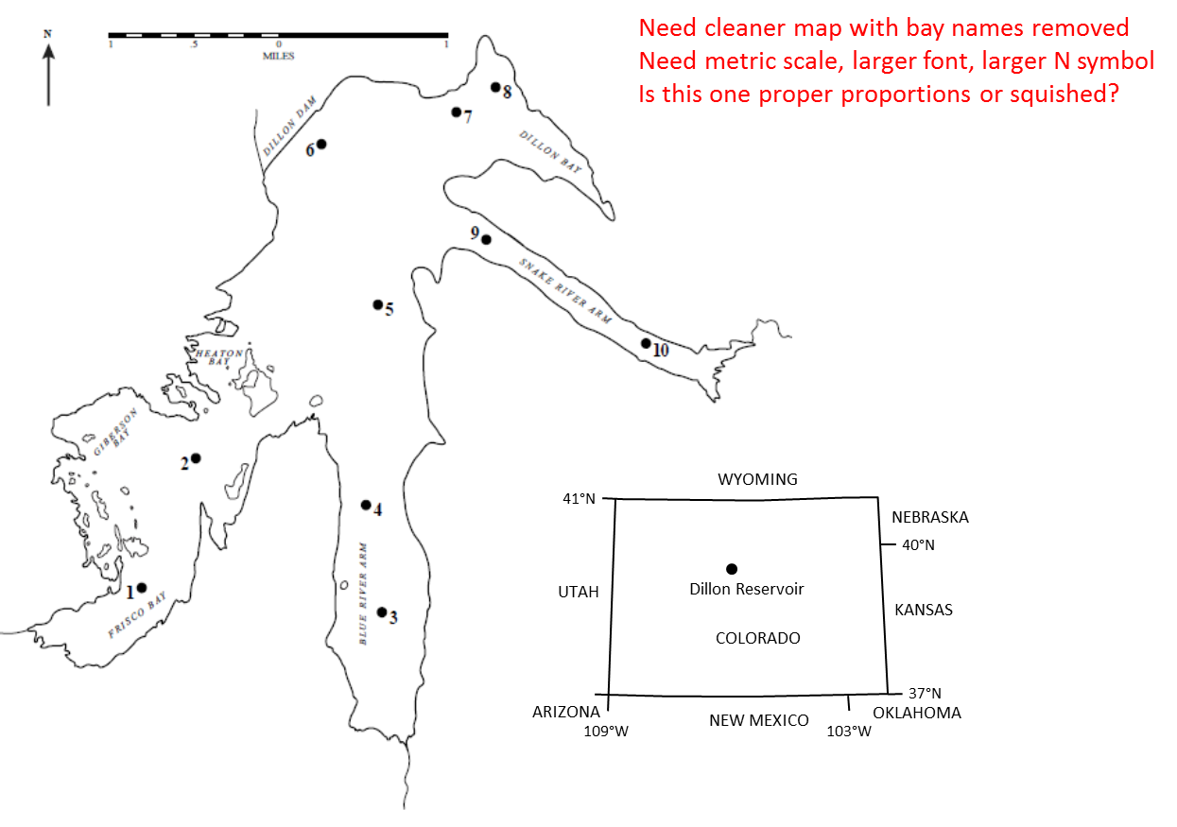

Figure 1. Ten locations on Dillon Reservoir, Colorado sampled with simultaneous tows of 0.5 m and 1.0 m diameter plankton nets.

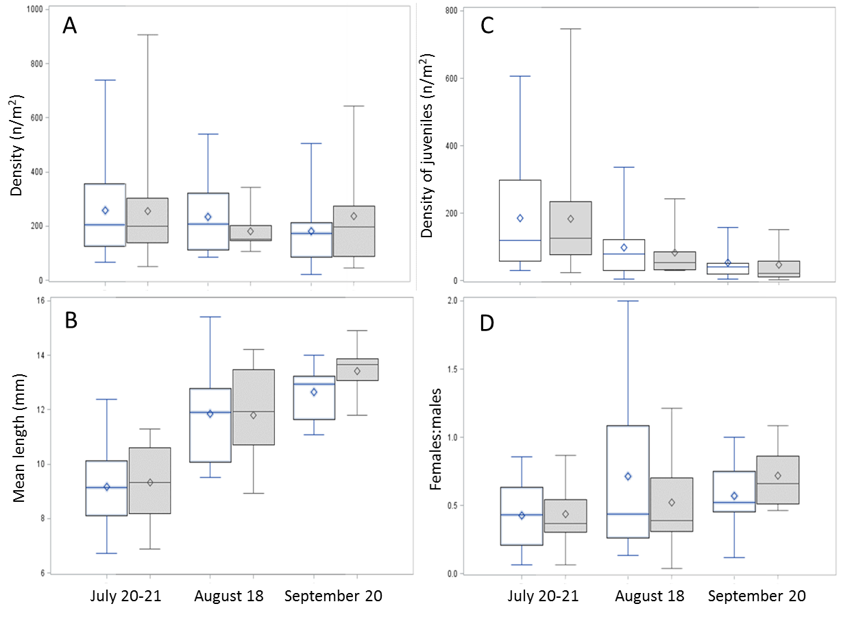

Figure 2. Density (A), mean length (B), density of juveniles (C) and sex ratio (D) of mysids sampled with and 0.5 m (white) and 1.0 m (gray) plankton nets at Dillon Reservoir, Colorado.

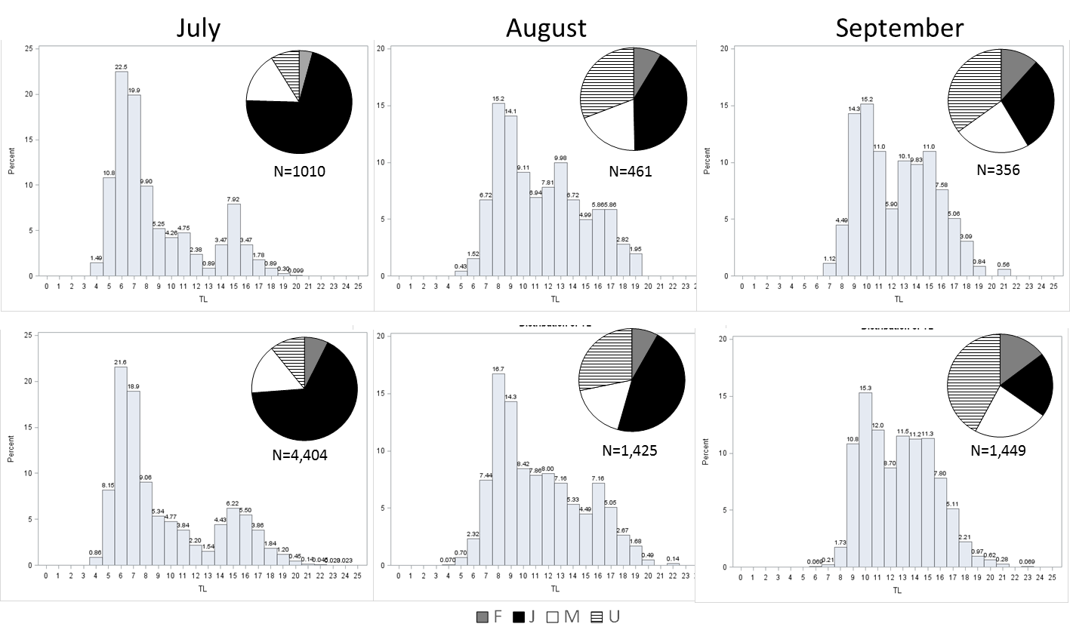

Figure 3. Lifestage/sex composition (pie charts) and length-frequency distributions of Mysis diluviana sampled with 0.5 m diameter (upper panels) and 1.0 m diameter (lower panels) plankton nets during three months in 2014 at Dillon Reservoir, Colorado. Sample size (N) is also shown. Black represents juveniles, gray represents females, white represents males, and hatched represents adults of undetermined sex.

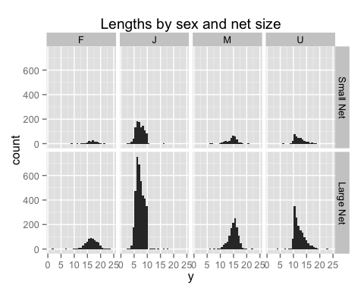

Figure 4. Plot of length distribution of *Mysids* between net sizes broken down into sex classes.

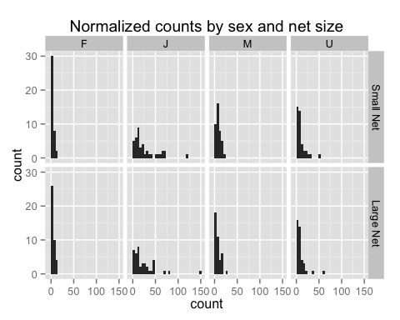

Figure 5. Plot of counts (normalized to equal area) broken down by sex class and net size.

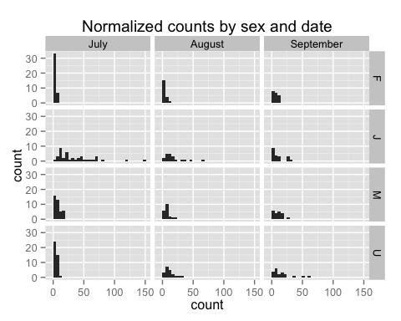

Figure 6. Plot of counts (normalized to equal area) broken down by sex class and sampling date/